FML FINAL PROJECT

PRAVALIKA

2022-12-17

##calling the required library

library(factoextra)

## Warning: package 'factoextra' was built under R version 4.2.2

## Loading required package: ggplot2

## Welcome! Want to learn more? See two factoextra-related books at https://goo.gl/ve3WBa

## Reading the csv file

Mall_Data<- read.csv("C:/Users/girne/Downloads/Mall_Customers.csv")

##printing the top portion data file

head(Mall_Data)

## CustomerID Gender Age Annual.Income..k.. Spending.Score..1.100.  
## 1 1 Male 19 15 39  
## 2 2 Male 21 15 81  
## 3 3 Female 20 16 6  
## 4 4 Female 23 16 77  
## 5 5 Female 31 17 40  
## 6 6 Female 22 17 76

##Taking the quantitative variables in order to scale.

Mall_Data1<-Mall_Data[,4:5]  
head(Mall_Data1)

## Annual.Income..k.. Spending.Score..1.100.  
## 1 15 39  
## 2 15 81  
## 3 16 6  
## 4 16 77  
## 5 17 40  
## 6 17 76

#Finding the value of K-means using unsupervised learning. Wanted to use the simplest, but most accurate method possible.

fviz_nbclust(Mall_Data1,kmeans,method="wss")+geom_vline(xintercept = 2,linetype= 5)+labs(subtitle = "Elbow Method")

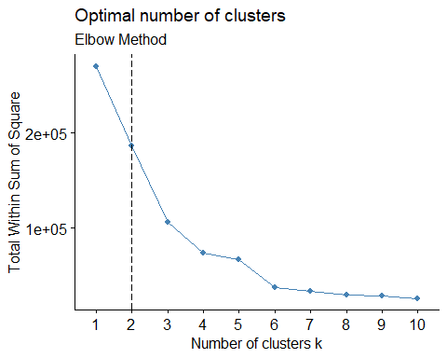

fviz_nbclust(Mall_Data1,kmeans,method ="silhouette") + labs (subtitle = "Silhouette Method")

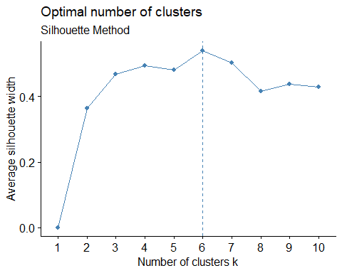

#Here, I will set the seed for kmeans.   
set.seed(456)  
k5<-kmeans(Mall_Data1, centers = 2, nstart = 50)  
k5$centers

## Annual.Income..k.. Spending.Score..1.100.  
## 1 37.28889 50.28889  
## 2 79.60000 50.12727

#Thus, K= 5, meaning that there will be 5 clusters.

#Clustering the data from .csv file.   
Mall_Dataclus<-kmeans(Mall_Data1,5)  
  
Mall_Dataclus

## K-means clustering with 5 clusters of sizes 30, 35, 76, 48, 11  
##   
## Cluster means:  
## Annual.Income..k.. Spending.Score..1.100.  
## 1 75.20000 82.56667  
## 2 88.20000 17.11429  
## 3 56.31579 49.52632  
## 4 27.06250 47.70833  
## 5 108.18182 82.72727  
##   
## Clustering vector:  
## [1] 4 4 4 4 4 4 4 4 4 4 4 4 4 4 4 4 4 4 4 4 4 4 4 4 4 4 4 4 4 4 4 4 4 1 4 4 4  
## [38] 4 4 4 4 1 4 4 4 4 4 4 4 4 3 3 3 3 3 3 3 3 3 3 3 3 3 3 3 3 3 3 3 3 3 3 3 3  
## [75] 3 3 3 3 3 3 3 3 3 3 3 3 3 3 3 3 3 3 3 3 3 3 3 3 3 3 3 3 3 3 3 3 3 3 3 3 3  
## [112] 3 3 3 3 3 3 3 3 3 3 3 3 1 2 1 3 1 2 1 2 1 3 1 2 1 2 1 2 1 2 1 3 1 2 1 2 1  
## [149] 2 1 2 1 2 1 2 1 2 1 2 1 2 1 2 1 2 1 2 1 2 1 2 1 2 1 2 1 2 1 2 5 2 5 2 5 2  
## [186] 5 2 5 2 5 2 5 2 5 2 5 2 5 2 5  
##   
## Within cluster sum of squares by cluster:  
## [1] 7018.167 12511.143 8313.368 44258.729 2823.818  
## (between_SS / total_SS = 72.2 %)  
##   
## Available components:  
##   
## [1] "cluster" "centers" "totss" "withinss" "tot.withinss"  
## [6] "betweenss" "size" "iter" "ifault"

fviz_cluster(Mall_Dataclus,Mall_Data1)

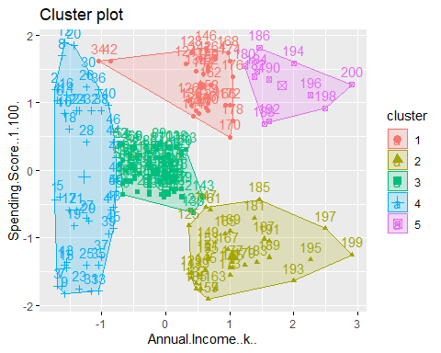

#Now, I will visualize the clusters.   
ggplot(Mall_Data1, aes(x = Annual.Income..k..,y = Spending.Score..1.100.)) +geom_point(stat = "identity", aes(color=as.factor(Mall_Dataclus$cluster)))+ scale_color_discrete(name="k",breaks=c("1", "2", "3", "4", "5"),labels=c("Cluster1", "Cluster2","Cluster3", "Cluster4", "Cluster5"))+ ggtitle("Mall_Datacustomer Segmentation")

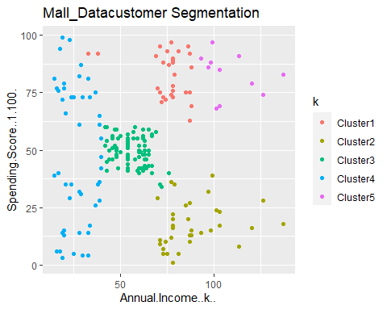

#Thus, the following can be concluded:  
#Cluster 1 are Mall_Datacustomer who earn a medium annual income and have a medium annual spending rate.   
#Cluster 2 Mall_Datacustomer who have a high annual income and a low annual spending rate.   
#Cluster 3 costumers who have low annual incomes and a high annual spending rates.  
#Cluster 4 Mall_Datacustomer with high annual incomes and have high annual spending rates.   
#Cluster 5 shows that Mall_Datacustomer with low annual incomes and low annual spending rates.